CURRICULUM VITAE

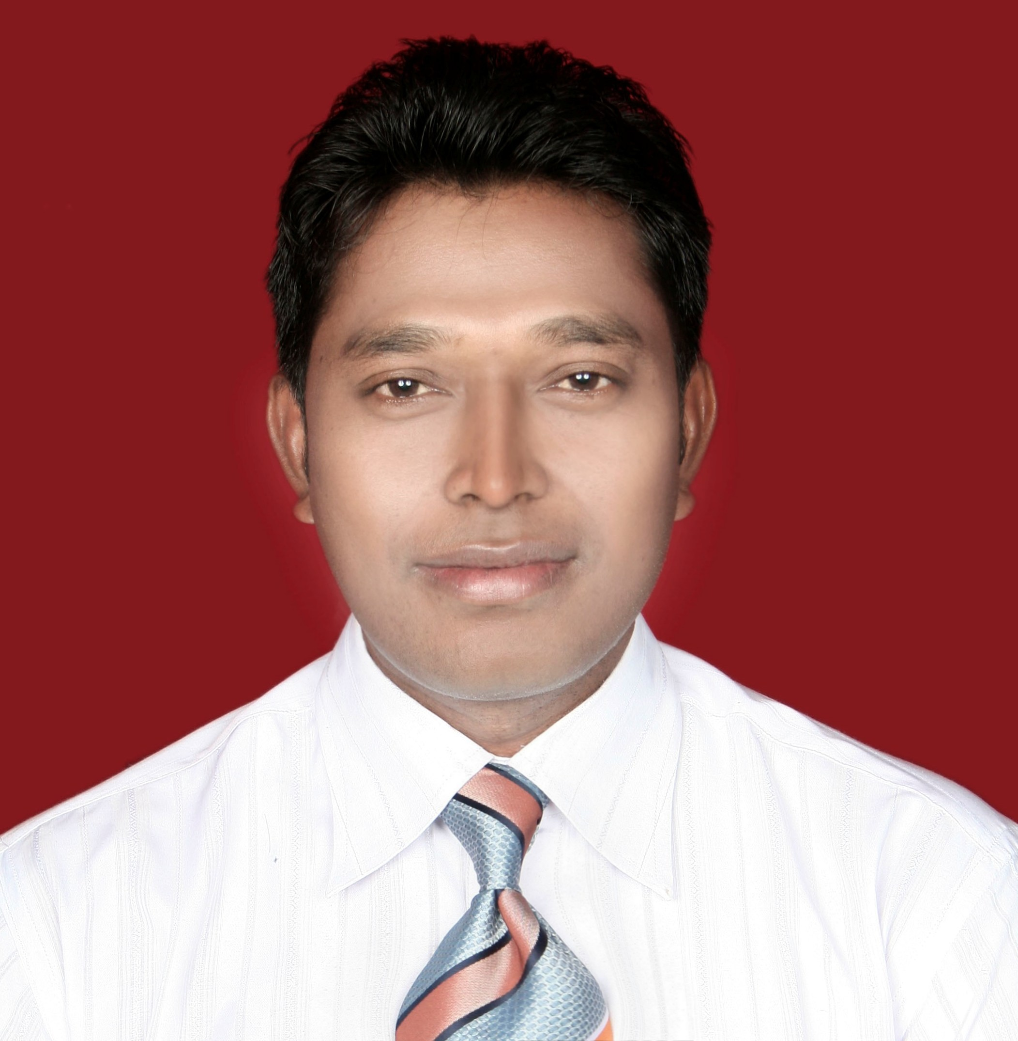

OBJECTVIES

A strong positive self-image which is the best possible preparation in success of life is the way, I take up things in building a strong and successful career and to grow up with the professionally managed learning organization and to work in a challenging environment requiring constant development of fresh skills and to utilize my existing skills to the maximum

PERSONAL INFORMATION

Name : Susil Kujur
Date of Birth : 14th July 1973

Mailing Address :
202,20th Cross
Pearl Garden road ,Ejipura
Bangalore
e-Mail: susilanshi@gmail.com
Mobile no: +918073185421

EDUCATIONAL QUALIFICATION

- Passed Matriculation from D.A.V School, H.A.L

Passed Bachelor Degree in Commerce from D.A.V College, Berhampur University in the Year 1995.

PROFESSIONAL QUALIFICATION

Three Year Diploma in Hotel Management in the year 1999 from Institute of Hotel Management Catering Technology & applied Nutrition, Bhubaneswar (National council for Hotel Management, Pusa, New Delhi)
- One year Diploma in Computer Application from JJCS, CSI, Mumbai.

EXPERINCE

-Currentlyworking as Head Sales & Marketing at DISCOVERY VILLAGE , Bangalore from March 2019.

-Worked as Head Sales for Shilton Hospitality LLP from 15th of March 2018 to Feb-2019
Taking care of the Sales & Marketing –OTA,RFP,CVGR ,Channel ,Corporates ,Revenue ,Team handling for the two unit with upcoming 4star hotel ,Chennai and based at Bangalore.
29 month worked as Asst.Regional Sales Manager –South ,from June 2015 and Based at Bangalore for a Fastest Growing chain of Hotels in India with 18 Hotels across India.
Job Responsibilities
- Handling the sales activities for the Soth zone .
- Team Handling -04 sales personnel (Bangalore ,Kochi ,Chennai & Hyderabad )
- Monitoring the team to achieve the regional sales target.
- Ensure periodic reviews conducted for all the Sales and Marketing personnel to ensure targets
- Reporting to Head Sales -India
- Data Mining and CRM.
- Preparing the revenue MIS for the region.
- Identify new revenue market.
- Market analysis and identify the corporate located in different location so that they can feed Our different unit..
- Handling the corporates & travel agency of Bangalore , Mysore ,Chennai & Coimbatore market.
- Co-coordinating with al Unit.
- Blocking rooms according to guests requirements.
- Following up with the signed contracts, advance payments, rooming lists, arrival and departure of the guest, guest preferences as well as handling billing letters and vouchers and update the same on the system.
- Prepare reports which reflect the past, future and present group bookings, expected VIP guests .
- Handling the Guest Complaints and apologize mailing exercise .
- Accelerator he Complaints to the top management to Improve the services
- Loading rates that are applicable for travel agents.
- Responsible for planning and development the marketing plan and promotional strategies for
- Maintain the healthy relationship with booker.
- Analyze and monitor the variations from the budget and take necessary corrective actions
- Sales Admin.
- Target achievement. (80% south and 20 % for Other Region)

-Worked as Asst. Manager –Regional Sales in Chancery Group of Hotels (4* and 5* Hotel at Bangalore) from July 2013 to May 2015
Job Responsibilities
- Market study and making the Database.
- Locating to the Decision maker in Company/Corporate an taking the appointment.
- Meeting and presentation of the services to the Top Level post in Corporate.
- Exploring new business opportunities & organizing promotional events to tap profitable business and achieve set targets.
- Concept preaching /Regular follow up for the Business close up.
- Mapping client's requirements and providing them customized business solutions through new proposals, presentations and demonstrations.
- Tracking Competitor Activities.
- Reporting to Director Sales .
- Develop marketing initiatives to expand customer base and to optimize sales.
- Lead generation through different Chanel and sources /Business Source research.
- Channel Sales / Corporate Sales-Regional/B2B Sales/ATL & BTL
- Costing/Quotation.
- Online promotional exercise/e mail management.
- To manage the marketing department budget.
- Corporate Contracting
- Handling 01 Executive
- Executing tie-ups, Promotional Activities and events in up metro markets.
- Responsible for developing existing business and secure new large clients who are in the business of property management/facility management services – Marketing and client relations- conducting market surveys and analysis.
- Negotiation & Costing.
- OTA management
- Handling the Regional Virtual Office Independently.

Fourteen months worked ( Nov 2011to June 2013)for Sun N Sand Group of Hotels
Job Responsibilities
- Handling Hyderabad Market
- Lead generation through different sources, prospecting and customer servicing.
- Team Handling
- Identify new revenue streams .
- Room ,Banquet and event sales actives.
- Monitor the Sales team.
- Co-coordinating with the reservation team and with all respective general Manager to provide the smooth services to the Guest.
- Handling the travel agency from Vijaywada and viza ,channel sales ,South film Industry and Corporate sales actives .
- Conducting PR party.
- Participating in Travel fair and exhibition to promote Our Hotel in Hyderabad.
- Target achievement.
Nine months worked ( Feb 2011 to Oct 2011)for Leonia Holestic Destination as Dy.Manager-Sales & Marketing
Job Responsibilities
- Handling the Financial & PSU Company vertical Team Handling of 01 Asst.Manager sales and 02 Sales Executive.
- Data mining
- Identify the new market.
- Reporting to the Sales Manager
- Blocking rooms / Venue according to guests requirements.
- Negotiate the Rates.
- CVGR Process
- Renewal of the contract.
- Monitor the team to follow the sales SOP and achieve the sales targets
- Co-coordinating with different department to offer the smooth services.
- Follow up the Outstanding.
- Target achievement.
Thirty months worked ( June 2008 to Oct 2010)for Silver Inn,4 star Hotel In Mumbai
Job Responsibilities
- Lead generation through Relationship Manager, prospecting and customer servicing.
- Team Handling of the Relationship Manager.
- Handling four centre(ICICI Direct) and DBC of north part of Orissa.
- Identify new revenue streams responsive to market demand.
- Co-coordinating for the Claims.
- Target achievement.

Twenty nine months worked ( June 2005 to Oct 2007)for ICICI Lombard General Insurance Co. Ltd, as Unit Sales Manager .
Job Responsibilities
- Lead generation through Relationship Manager, prospecting and customer servicing.
- Team Handling of the Relationship Manager.
- Handling four centre(ICICI Direct) and DBC of north part of Orissa.
- Identify new revenue streams responsive to market demand.
- Co-coordinating for the Claims.
- Target achievement.

Two year(Aug 2003 to April 2005) worked as Lecturer in AICTE approved Hotel Management College, Ranjita Institute of Hotel Management & Catering Tech.,Bhubaneswar.
Job Responsibilities
- Taking Theory and practical classes of Food & Beverage Service
- Training & Placements
- Administration & Admission Counseling
- Conducting seminars.
- In charge of Guest House and Facilities Management of the Organization (House Keeping,Banquets, Confrences, Ticketing,Maintainance).

Three Years (1 July 1999 to 10 Aug 2003)worked as Management Trainee, Promoted Manager (Sales & Marketing) in Four star Hotel, The New Marrion, Bhubaneswar.

Job Responsibilities

- Cold call-Telephonic ,Taking the appointment and meet to the clients.
- Travel agent handling for the Hotels booking-group and Holiday Package.
- Guide, train and lead the sales associates/executives on how to handle their portfolio, cover the
market and ensure business comes .
- Support executives in ensuring optimal coverage of their markets i.e. information (on accounts) and relationship building. Hand holding individual team members in their interaction with key accounts.
- Understand size and nature of business (for value conscious travelers)
- Meet with all decision makers and influencers and establish a relationship
- Negotiate corporate rates
- Preplan monthly travel schedule for each city, to enable smooth on ground co-ordination
- Tracking and analyzing market data i.e vis-à-vis competition + market developments
- Comprehensive market knowledge – competition (existing and new), changing business environment, changing infrastructure
- Product development ideas – based on market and industry trends. Provide inputs to marketing team
- Coordinate execution of marketing initiatives Together with SM/Director
- Supervise any external communication e.g. press event, marketing activity
- Recommending new markets/cities. Feed into the business development effort of the company - assess new opportunities and give recommendation.
- Finalized the price of the banquets with Coordination with F&B manager, Chef and Banquets Manager.

Six months Industrial Training from a five star Deluxe Hotel
CENTAUR HOTEL JUHU BEACH, Mumbai in the year 1997.
Job Responsibilities

- Table Lay out, Mis-en-place, wiping cutleries and other F&B equipments, Service, Taking Order, Banquet & Buffet set up in F&B Service.
- Handling EPBX, Taking Reservation through mail, fax, Phone. In Front Office
- Cleaning, dusting, bad Makings, Morning and Evening Service, Supervising Floor & public Area in Housekeeping.
- Mis-en-place, Helping Chef for Kitchen activities. Portion control, Handling pantry.
Stores requisition in the Food and Beverage production Dept.

OTHER EXPOSURE /CURRICULAR ACTIVITIES

- Practicing HR Process as a freelancer.
- Handled the table manner training for the Infosys Technologies Ltd. Employees.
- Guest faculty for the Soft skill in one of the finest B school in Orissa, Asian School of Business Management.
- Setup of Kitchen and Dining area for Infosys Technologies Ltd and House Keeping operation.
- Represent the Hotel in the Trade Fair.
- Participate in various Fair.
- Played Inter College and district level Badminton tournament.

CURRENT CTC :9,60,0000 Per annum (Mobile ,Laptop ,Data ,Food )
Expected Salary-As per the company standard ,Variable & allowances

LANGUAGES CONVERSATION
- English
- Hindi
- Oriya.
- Bengali
DECLARATION

I hereby declare that all the statement furnished in this CV is true and correct to the best of my knowledge.

Place: Bangalore. SUSIL KUJUR
Date:

